“Titanic: Machine Learning from Disaster”
Project report

1. Problem definition

When Titanic hit an iceberg a lot of passengers and crew died. In this challenge I need to predict what sorts of people were likely to survive. Data on which I will do my prediction was included into task.
2. Preparation of Data
2.1 Data overview
To take first overview of the data let's explore whole dataset (train and test data joined) using:
- info() function
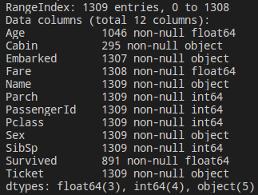

Fig 2.1.1 Dataset info.
- sample() function
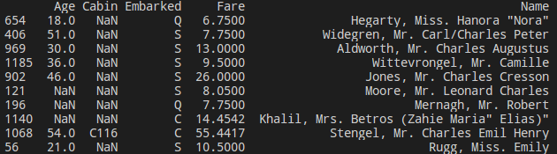
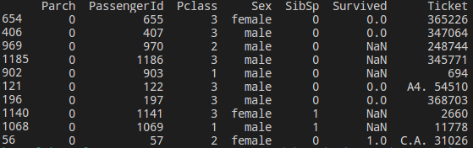
Fig 2.1.2 Ten samples of dataset.

- description() function
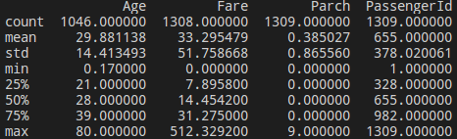

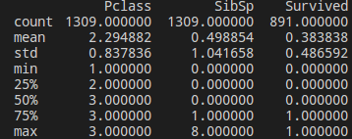

Fig 2.1.3 Dataset description.
There are 12 features which can be used for data analysis:
- Survived is a variable which need to be predicted
- PassengerID is assumed to be a random identifier and therefore will be exclded from analysis
- Pclass variable represents passenger status: 1 - upper class, 2 - middle class, 3 - lower class
- Ticket variable is a nominal datatype that can be used in feature engineering to check which passengers were travelling together (same ticket number)
- Cabin vaiable is a nominal dataype that can be used in feature engineering to approximate passenger's position on the ship when Titanic hit an iceberg
- Name vaiable is a nominal dataype that can be used in feature engineering to obtain passenger title
- Sex and Embarked variables are a nominal datatypes
- Age and Fare variables are continuous quantitative datatypes
- SibSp represents number of related siblings/spouse on board
- Parch represents number of related parents/children on board. Togather with SibSp can be used for feature engineering to create a family size variable
2.2 Outliers
Since outliers can have a dramatic effect on the prediction I decided to inspect if all numerical data look reasonable. From all numerical variables I analysed Fare, SibSP, Parch and Age (Pclass is not really numerical variable but categorised, PassengerID is excluded and Survived is categorical variable which I need to predict).
I based my judgement on statisic summary of the dataset (Fig 2.1.3):
- Age values are between 0.17 and 80 which is reasonable
- Parch are between 0 and 9 which is reasonable. Nine children/parents may look high at first but it wasn't unusual at that time to have many children.
- SibSP values are between 0 and 8 which is also reasonable.
- Fare values are between 0 and 512.3292 with mean 33.295479. Maximum value may look high at fist but there were high difference in passenger status. Some of them was really rich and had high quality rooms which could cost significantly higher comparing to standard tickets.
Since all numerical features have reasonable values I decided not to exclude outliers from original data.
2.3 Missing values
There ae missing values in Age, Embarked, Fare and Cabin fields. Before modelling records with missing values should be deleted, fixed or feature should be excluded from analysis. Let analyse each featue one by one.
2.3.1 Age
First of all I am going to plot age distribution for people who survived the tragedy and who died.
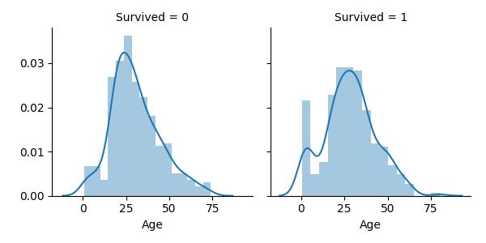
Fig 2.3.1.1 Age distribution vs Survived.
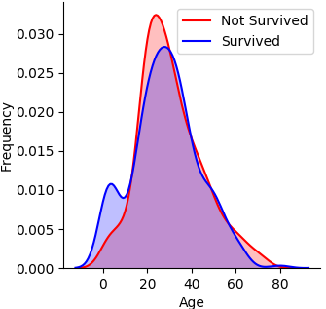

Fig 2.3.1.1 Age distribution vs Survived. Two distributions in one plot.

There is a clear difference between these two distributions. For “survival” distribution there is a peak for young passengers and group of old people (over 60) seems to be smaller comparing to “non survival” distribution. It looks like age is a valuable feature for survival prediction. Because of that it shouldn’t be excluded from analysis even there is significant amount of missing data in this field.
To impute the missing age values I used other features to calculate reasonable guess. I based on Parch, SibSp, Pclass and Sex .
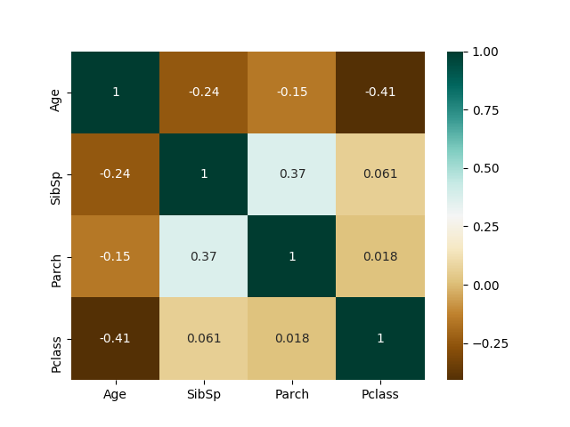
Fig 2.3.1.2 Correlation matrix fo Age, SibSp, Parch and Pclass features.
According to correlation matrix age is not correlated with sex but it is negatively correlated with Parch, SibSp and Pclass, positively with Fare. To visualize it more I created aproperiate plots.

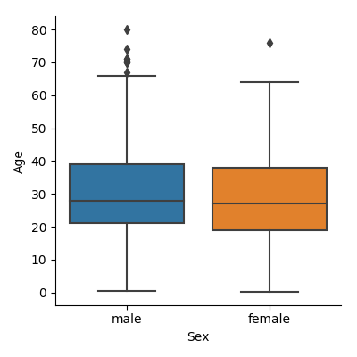

Fig 2.3.1.3 Age vs Sex box plots.
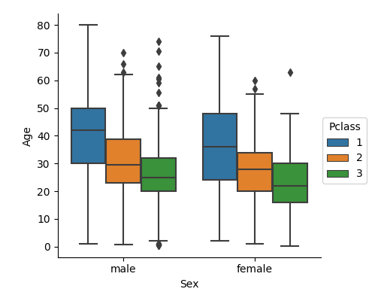

Fig 2.3.1.4 Age vs Pclass (male and female) box plots.

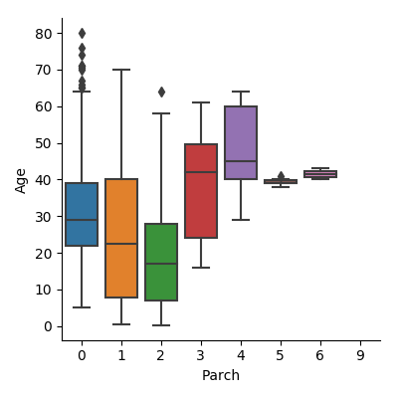

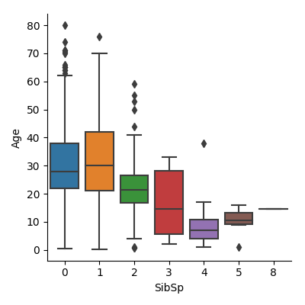
Fig 2.3.1.5 Age vs Parch box plots.

Fig 2.3.1.6 Age vs SibSp box plots.
I decided to use Parch, SibSp and Pclass features to predict missing age values.
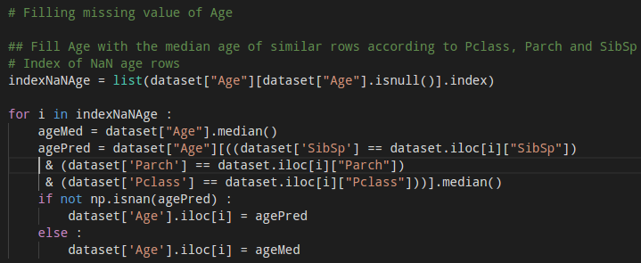
Fig 2.3.1.7 Filling missing Age values.
2.3.2 Cabin
Cabin field is a source of valuable information – where passenger probably was at the time when Titanic hit an iceberg. However, it has a lot of missing values (over 1000) which can introduce a lot of noise in prediction step. Eventually I decided to exclude this feature from future analysis.

2.3.3 Embarked
There are only 2 missing values so I decided to fill them with most frequent value which is “S”.
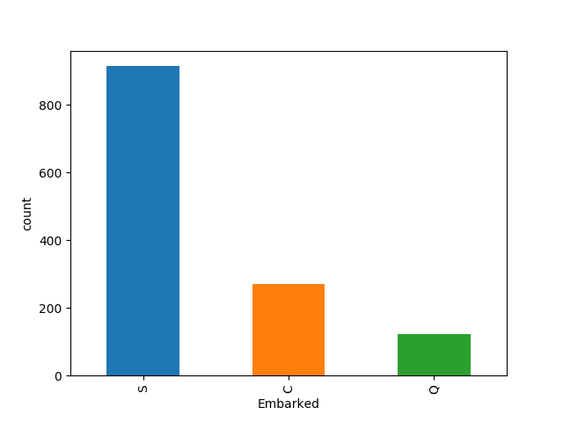
Fig 2.3.3.1 Countplot of Embarked feature.

2.3.4 Fare
There is only 1 missing values so I decided to fill it with median.
3 Feature Engineering
3.1 Title
Name feature despite first and second name includes passenger title. It is interesting to separate title as a feature to see what is survival probability for passengers with different titles.
There are 17 different titles in the dataset but most of them are very rare. They can be grouped into 4 categories:
- Mr
- Master
- Mrs/ Ms/Mme/ Miss
- Rare (Don, Sir, …)
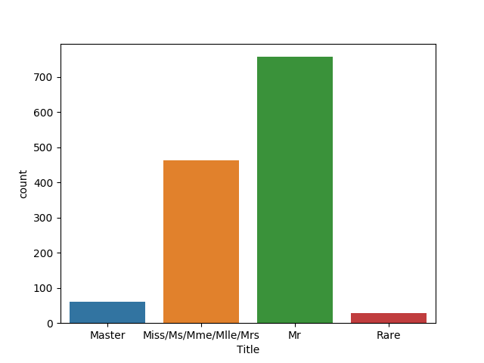
- Fig 3.1.1 Countplot of Title feature.

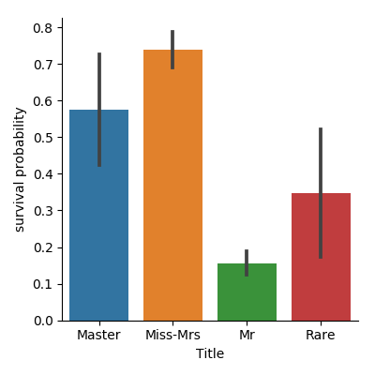

Fig 3.1.3 Title vs survival probability.
It looks like people with rare title had more chance to survive comparing to male with basic title (Mr.).
3.2 Family size
It is possible that size of a family had impact on survival probability of passengers. It is not easy to evacuate big family.
It is easy to construct family size feature basing on SibSp and Parch features. “Family” value is sum of SibSp, Parch and 1.

